COMHAIRLE CONTAE CHILL MHANTÁIN
WICKLOW COUNTY COUNCIL

COMMUNITY INVOLVEMENT SCHEME
APPLICATION FORM 2019

Closing date for return of application is Friday, 23rd August 2019.

Details of Road

- Location of Road
    - road number ___________________________________

    - townland_______________________________________

- Road Class: ___________________

- Length of Road to be included in scheme: _______________________________

- Width of Road between fences: _______________________________________

- Number of dwellings on road: _________________________________________

- Number of landowners (farms), other than residents on road: ________________

- Municipal District (Wicklow/Arklow/Baltinglass/Bray/Greystones): _____________

- Type of Works required:

_______________________________________________________________________

_______________________________________________________________________

Please attach copy of 6” O.S. Map or similar map indicating location of road and the terminal points of the proposed work and locations of habited dwellings.

Your application will be returned in the absence of a map identifying the proposed road to be included in CIS.

On receipt of the above information, Wicklow County Council will assess same under the following headings and prioritise roads based on the criteria below.

Certain requirements would apply to CIS schemes:

- Local authorities will assess the condition (PSCI) of any local roads, for which they intend to apply for funds, using the Paving Rating Manual (rating range is 1 to 10 with 1 being very poor and 10 being excellent). Where schemes are approved and proceed, the “after” condition must be subsequently rated.

- Local authorities would record the road length and width and the number of dwellings along the roads under consideration

- Local authorities would estimate the overall cost of the scheme taking account of material, labour, machinery and traffic management costs. The community contribution may in each case be in money or in kind (labour / machinery) or both. This will then determine the percentage contribution.

- Taking into account the findings of points 1 to 3, Wicklow County Council may then prioritise the roads for funding under Community Involvement Scheme up to and including 31st December 2021.

Terms and Conditions

- We, the undersigned, being members of a local community in County Wicklow, hereby apply to Wicklow County Council for participation in the Community Involvement Scheme to improve local public roads.

- We hereby appoint and delegate full power to

Name: ___________________________________ (please print name)

Address: ___________________________________________________

to act for us in all correspondence and other business arising out of this application and we agree to be bound by our nominee’s correspondence and acts.

- We agree to pay the monetary contribution as required in accordance with the scheme by the appropriate time period as defined by Wicklow County Council
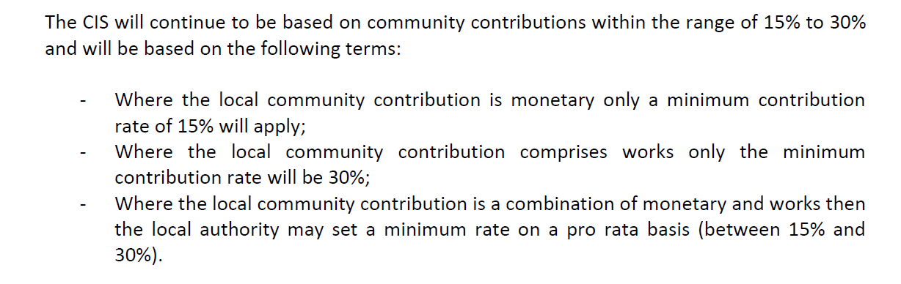

- We agree to carry out works required of us under the control and supervision of the Council and to the specification of the Council. We understand that claims arising from any works carried out by us outside the control and supervision of, or in a manner unsatisfactory to the Council, are not covered by the Council’s insurance.

- We accept the Council must satisfy itself that the works have been completed in a satisfactory manner before accepting subsequent responsibility for the road.

- We accept to exclude all vehicles and mechanically propelled plant from the works we will carry out which do not have proper Motor Insurance Cover.

- We undertake to report immediately any accident or claim to the Council arising out of the works and accept that the Council will have sole control over the handling or settlement of the claim.

- We undertake to be bound by the scheme’s exclusion of claims made for injury, loss or damage to individual persons who are part of the group, employees of persons who are part of the group, or family members of persons who are part of the group.

- The table below must be completed by all residents and landowners residing/owning land along the proposed road that is the subject to this CIS application.

Name  (Print Name) | Signature | Resident or Landowner | Address

Signature of Applicants’ Representative

______________________________________

Postal Address of Applicants’ Representative

_________________________________________________________________________

Telephone No. _________________________ Email _____________________________

Completed form to be returned to:-
Administrative Officer,
Wicklow County Council,
Transportation and Roads Department,
County Buildings,
Station Road,
Wicklow,
Co. Wicklow.
Tel: 0404 20100
e-mail: roadtrans@wicklowcoco.ie
www.wicklowcoco.ie
Respondents making submissions should note that Wicklow County Council is subject to the provisions of the Freedom of Information Act 2014 and the Data Protection Act 2018.

